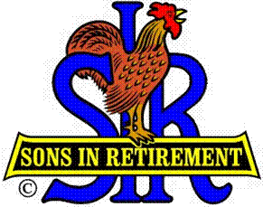

Las Trampas Branch 116

Executive Committee Meeting Agenda

October 16, 2017
9:30 AM
- Call Meeting to Order and confirm we have a quorum.
- Review Agenda/Minutes for Changes/Additions.
- Standing Reports:
Secretary – Fred Schafer – Approval of September 18, 2017 minutes
Attendance – Sam Beret
Head count, missed luncheon receipts
Membership – Phil Goff
New Members to be inducted:
Guests Today:
Visitors:

- Budget – Jim Nickles

- Big Sir Report:
- Storyteller: Bob Testa
- Chaplain: Matt Arena
- North Bay Fires
- HLM Award and Senior SIR Awards.
- 2018 Officer Nominations – Membership Voting
- Leadership Identification Form – Jerry Hicks

- Little Sir Report:
- SIR Training Session – October 13, 2017
- October Speaker: Fumble Fingers the Magnificent (Astonishing)
- November Speaker:
- Other

- Other Reports

- Adjourn – 10:15 am

